What is Chemistry and why is it important?
Chemistry is the study of substances; what they are made of, how they interact with each other and the role they play in living things. The skills you develop while studying for a chemistry qualification are highly desirable to employers in all sorts of sectors. Skills like logical thinking, communication, creativity, analysis, data handling and observation. Whether you know what you want to do after university or you’re still unsure, chemistry stands you in good stead for the future.
What do we do in Leaving Cert Chemistry?
Leaving Cert. Chemistry is comprised of all the essential and relevant topics within general chemistry. The major topics involved include the following:
- Atomic structure
- Volumetric analysis
- Organic chemistry
- Water chemistry
- Reaction mechanisms
There also is an option to be taken as part of the course which involves the study of atmospheric and industrial chemistry or the study of materials and electrochemistry.
Experimental investigations are an essential part of the leaving certificate course. Experimental work is examined as part of the leaving cert exam and forms the basis for a minimum of three questions on the exam paper.
What kind of a student takes Chemistry?
Are you interested in laboratory work? Did you enjoy junior cert science? Do your like problem solving? These students tend to enjoy chemistry for the Leaving Cert.
What is Chemistry a requirement for in Third Level?
Chemistry is a requirement for the following third level courses -Dentistry (UCC), Human Nutrition & Dietetics (DIT), Medicine - Undergraduate Entry (UCC), Pharmacy (Trinity College, UCC), Veterinary Medicine - Undergraduate Entry (UCD)There are 211 courses listed on the CAO that require a science subject (some require 2) with chemistry being preferred .
What jobs could a qualification in chemical science lead to?
All sorts! Chemical scientists work in a huge variety of careers both in and out of the lab, including many you might not have thought about before.
- Nanotechnology – designing structures on an atomic scale for use in medicine, communication and industry
- Environmental science – understanding and safeguarding our environment
- Sustainability – developing alternative energy sources for a cleaner, healthier planet
- Innovation – developing exciting new technology products
- Product development – improving our cosmetics, toiletries and household cleaning products
- Forensics – helping to solve crimes
- Archaeology – dating and analyzing artifacts
- Drug discovery – discovering new medicines
- Biotechnology – seeking treatments for diseases, experimenting with new energy sources and creating the next generation of consumer chemicals
- Marine chemistry – reducing pollution and discovering new natural compounds for use in food production and medicines
- Sportswear development – producing smart new materials for trainers, lightweight materials for bike frames and racquets, or aerodynamic suits for cycling and athletics
- Teaching – inspiring the next generation of chemists
- Food technology – inventing new foods or flavour

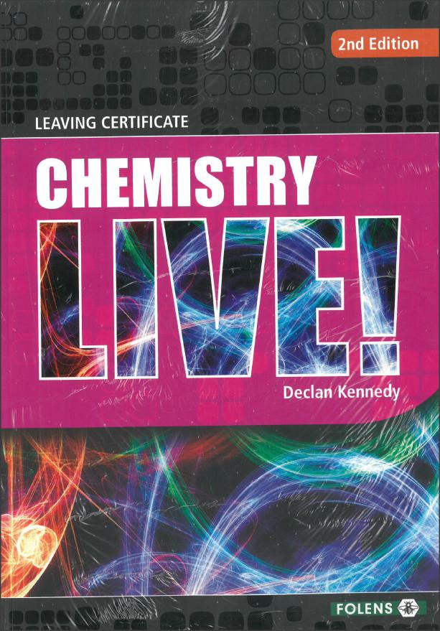

Publisher: Folens
Author: Declan Kennedy
Chemistry Live textbook
Chemistry Live Workbook
Hardback A4 Science copy
Hardback A4 Notes copy
Homework copy

Exam structure:
The leaving cert exam is three hours written paper. Each candidate must answer eight out of eleven questions on the paper with at least two questions from Section A (experimental section). Each question carries fifty marks, so the paper is worth 400 marks.
There is no element of continuous assessment but experimental copies must be available for inspection by the State Examinations Commission.

Comments
- It is recommended that a student undertaking the course has a good understanding of Junior Cert Science at the Higher Level.
- A student would be expected to have a reasonable level Maths (Higher Level Junior Cert at a minimum). Approx 40% of the LC Chemistry course has a mathematical component.
- Being a logical thinker and having an aptitude for accuracy & hard work are essential.
“Chemistry exists everywhere not just in laboratories but in every living thing on land and sea and in our bodies. It is often described as 'the central science' containing a lot of formulas. So, if you enjoyed Junior Cert Science and you have done well in this and Maths you should be a good candidate for Leaving Cert Chemistry. Chemistry is an essential element in the study of careers including: Medicine, Dentistry, Veterinary Science, Physiotherapy, Pharmacy and Medical Laboratory Technology”.
% Grades at Higher Level

